**KENDRIYA VIDYALAYA (SAC) VASTRAPUR**



**ACADEMIC YEAR: 2021-22**

## SYNOPSIS OF THE PROJECT

## BANK MANAGEMENT SYSTEM

|  |  |
| --- | --- |
|  |  |
| **ROLL NO** | **: 18** |
| **NAME** | **: Shashwat G. Patil** |
| **CLASS** | **: XII** |
| **SUBJECT** | **: COMPUTER SCIENCE** |
| **SUB CODE** | **: 083** |

**PROJECT GUIDE: MRS. RENU BAHETI**

**PGT (CS)**

**KENDRIYA VIDYALAYA VASTRAPUR**

**CERTIFICATE**

This is to certify that ________________________ Roll No : ___ has successfully completed the project synopsis work entitled **Bank Management System** in the subject Computer Science (083) laid down in the regulations of CBSE for the purpose of Practical Examination (Term I) in Class XII to be held on ___________.

External Examiner Mrs. RENU BAHETI

PGT (Computer Science)

Signature Signature

Principal's Signature

|  |  |  |
| --- | --- | --- |
|  | **TABLE OF CONTENTS [ T O C ]** |  |
| **Sr. No** | **DESCRIPTION** | **PAGE NO** |
| 1 | INTRODUCTION OF THE PROJECT | 4 |
| 2 | OBJECTIVES OF THE PROJECT | 5 |
| 3 | SCOPE OF THE PROJECT | 6 |
| 4 | PROPOSED SYSTEM | 7 |
| 5 | HARDWARE AND SOFTWARE REQUIREMENTS | 9 |
| 6 | SYSTEM DESIGN | 10 |
| 7 | DATABASE DICTIONARY | 13 |
| 8 | REFERENCES AND BIBLIOGRAPHY | 15 |

# INTRODUCTION

The Bank Management System is basically a database-based project done with help of the Python language. Bank Management System is a computer system that helps manage the information related to Banking and aids in the job completion of the bank effectively. They manage the data related to all departments of Bank such as Account details, Personal INFO, Customer care, Loans, etc.

Bank Management System provides the ability to manage all the paperwork in one place, reducing the work of staff in arranging and analysing the paperwork of the customers.

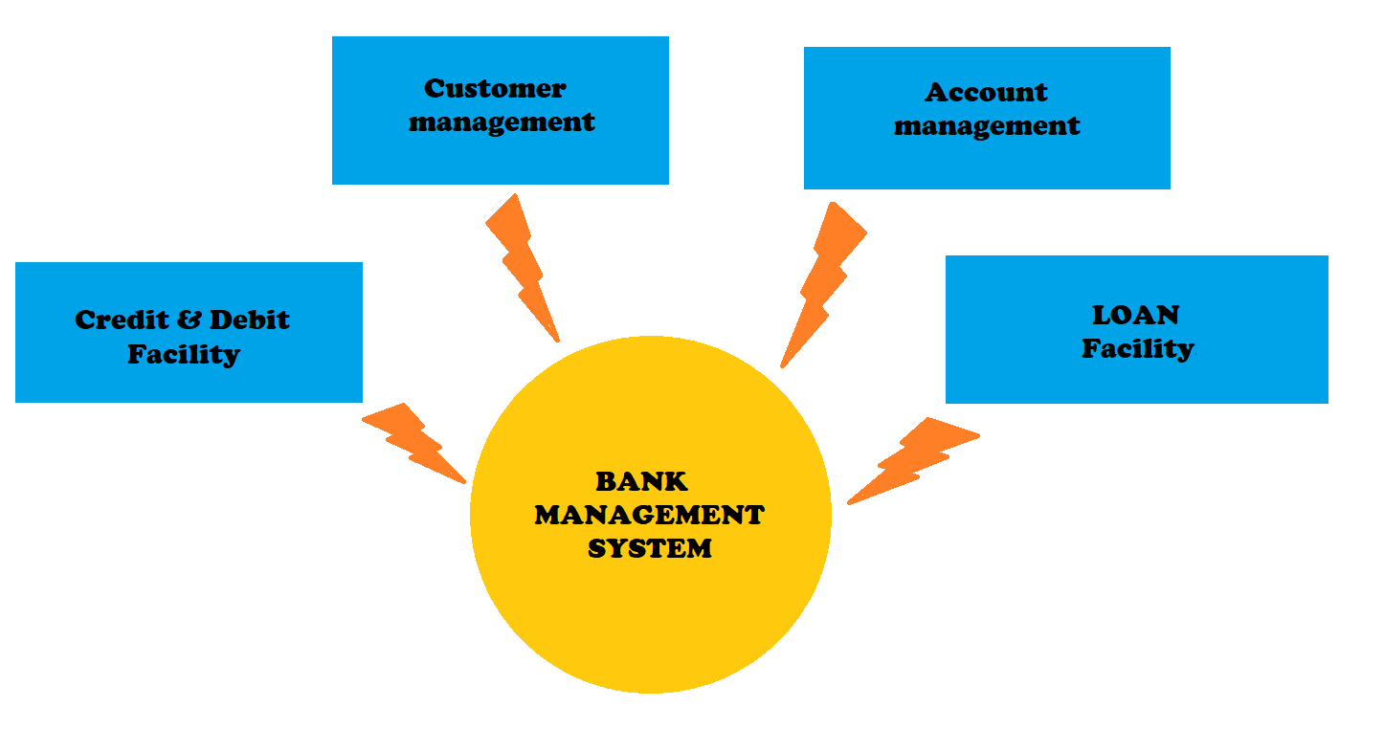

# OBJECTIVES OF THE PROJECT

The objectives of the system are:

* Maintain the financial records of the customer
* Maintain the personal details of the customer
* Tracking the bill payments
* Reduces the work of documentation
* Reduced operational time
* Increased accuracy and reliability
* Increased operational efficiency
* Data security
* Cost effective and easily manageable

This software package can be readily used by non-programming personal avoiding human handled chance of error.

# SCOPE OF THE PROJECT

This project has a large scope as it has the following features which help in making it easy to use, understand and modify it:

* Easy to online drafting.
* No Need to do Paper Work.
* To save the environment by using paper free work.
* To increase the accuracy and efficiency of the placement procedure.
* Management of Market Data.

Main Points are:

* Simplified Management of User Profiles
* Booking Details
* Bank Information

# PROPOSED SYSTEM

In order to compete with other nations in the fight or superiority, the only method to prevail, is by strengthening the nation by in several ways including its financial stability. Banking activities are considered to be the life line of any nation's economy.

Without banking services, trading and business activities cannot be carried out smoothly. Banks are the distributors and protectors of liquid capital which is of vital significance to a developing country.

An efficient administration of the banking system foster in the economic growth of the nation.

Today one cannot afford to rely on the fallible human beings. It is now become outdated to rationalize your mistake. So, in order to keep pace with time, to bring about the best result without malfunctioning and greater efficiency so as to replace the un-ending heaps of paper files with a much sophisticated hard disk of the computer.

This prevents a lot of wastage of time and money. The work becomes fully automated and any information regarding the organization can be obtained by clicking the button.

Softwares have been an ascent in atomization in various organisations. Many software products working are now in markets which have helped in making the organizations work easier and efficiently. Data management initially had to maintain a lot of ledgers and a lot of paper work has to be done but gradually software product on this organization has made their work faster and easier. Now only this software has to be loaded on the computer and work can be done.

Moreover, now it's an age of computers and updating and upgradation is the best method to sustain and develop in order to compete with the increasing pace of this generation.

## HARDWARE AND SOFTWARE REQUIREMENTS

Hardware Requirements:

I. OPERATING SYSTEM: WINDOWS 8 AND ABOVE

II. PROCESSOR: PENTIUM (ANY) OR AMD ATHALON (3800+- 4200+ DUAL CORE)

III. MOTHERBOARD: 1.845 OR 915,995 FOR PENTIUM 0R MSI

K9MM-V VIA K8M800+8237R PLUS CHIPSET FOR AMD ATHALON

IV. RAM: 512MB+

V. Hard Disk: SATA 40 GB OR ABOVE

VI. CD/DVD r/w multi drive combo: (If Backup required)

VII. PEN DRIVE 32 GB: (If Backup required)

VIII. MONITOR 14.1 or 15 -17 inch

IX. Key board and mouse

X. Printer: (if print is required - [Hard copy])

Software Requirements:

• Windows OS

• Python 3.7. x

• MySQL connector module

## SYSTEM DESIGN

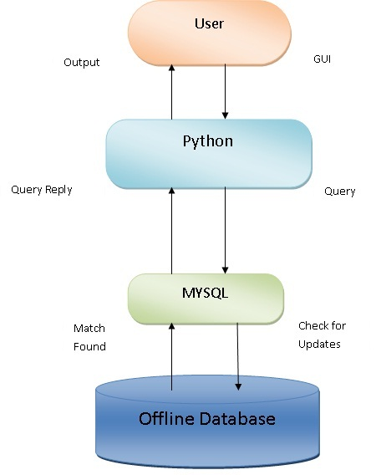

**SYSTEM DEVELOPMENT LIFE CYCLE (SDLC)**

The systems development life cycle (SDLC), also referred to as the application development life-cycle, is a term used in systems engineering, information systems and software engineering to describe a process for planning, creating, testing, and deploying an information system. The systems development life-cycle concept applies to a range of hardware and software configurations, as a system can be composed of hardware only, software only, or a combination of both.

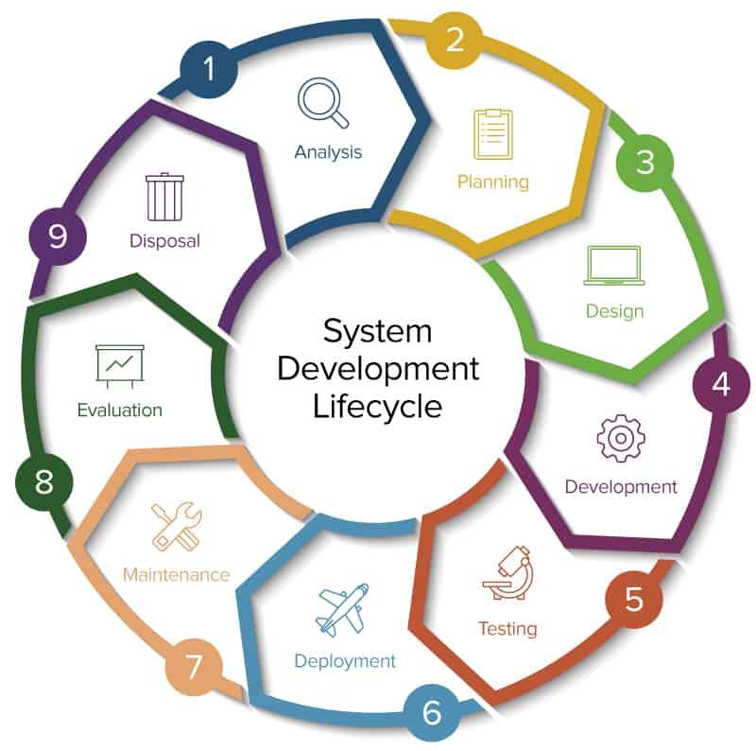

**PLANNING AND REQUIREMENT ANALYSIS**

Requirement analysis is the most important and fundamental stage in SDLC. It is performed by the senior members of the team with inputs from the customer, the sales department, market surveys and domain experts in the industry. This information is then used to plan the basic project approach and to conduct product feasibility study in the economical, operational, and technical areas.

**Defining Requirements**

Once the requirement analysis is done the next step is to clearly define and document the product requirements and get them approved from the customer or the market analysts. This is done through .SRS. . Software Requirement Specification document which consists of all the product requirements to be designed and developed during the project life cycle.

The systems development life cycle is a project management technique that divides complex projects into smaller, more easily managed segments or phases.

# DATABASE DICTIONARY

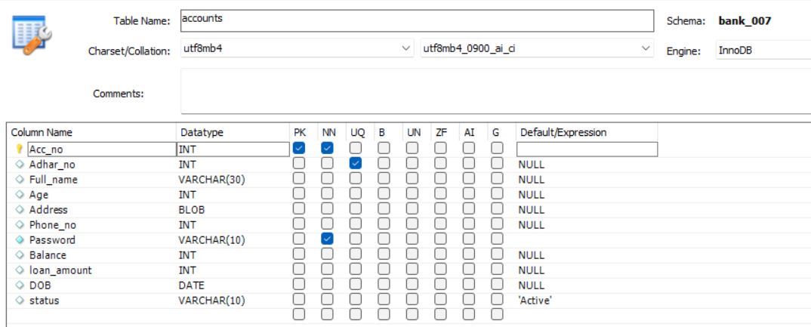

# QUERY/FEEDBACK/RESPONSE TABLE

**Relationship between Customer and Query**

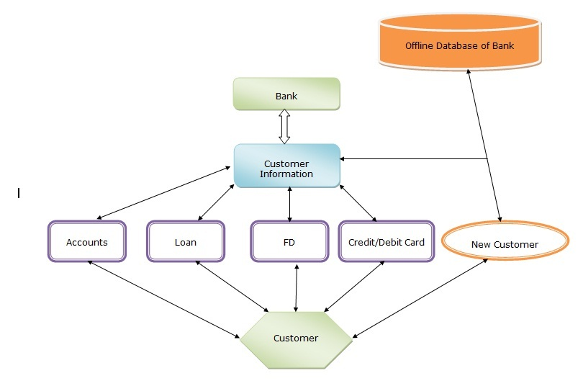

# SOURCE CODE

I have divided the database management system in 5 different python files for frontend and the backend is MySQL **8.0**.

User Defined Module named M_db.py is the module to create a database on the computer and just needs to be ran once.

# 

User Defined Module named M_st.py is the module to create a table structure in MySQL and just needs to be ran once.

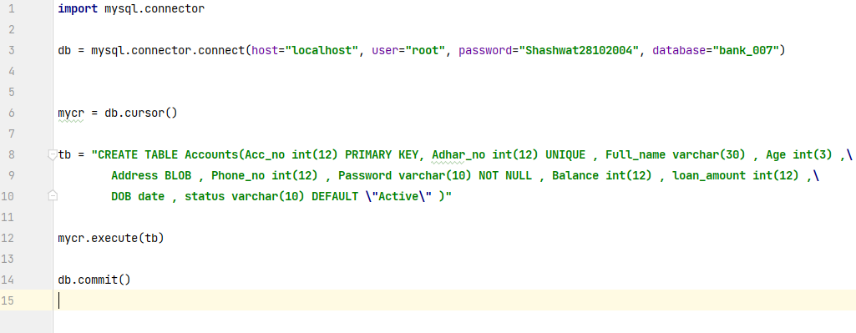

User Defined Module named M_st.py is the main module that contains all the functions of the project like adding data, updating, deleting etc.

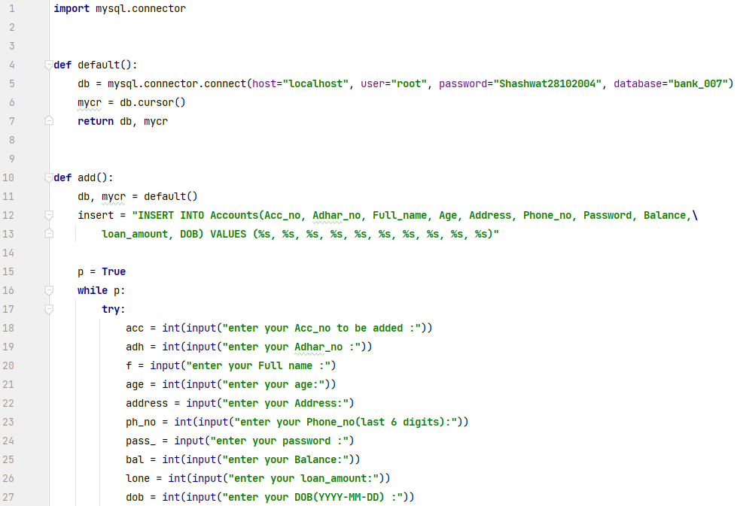 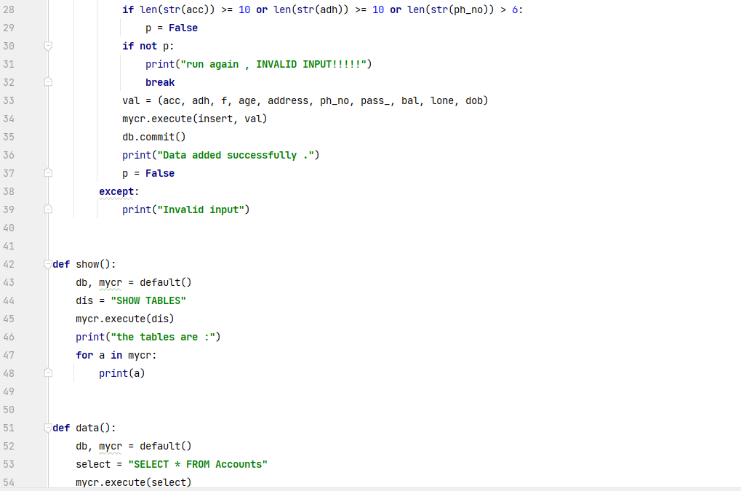

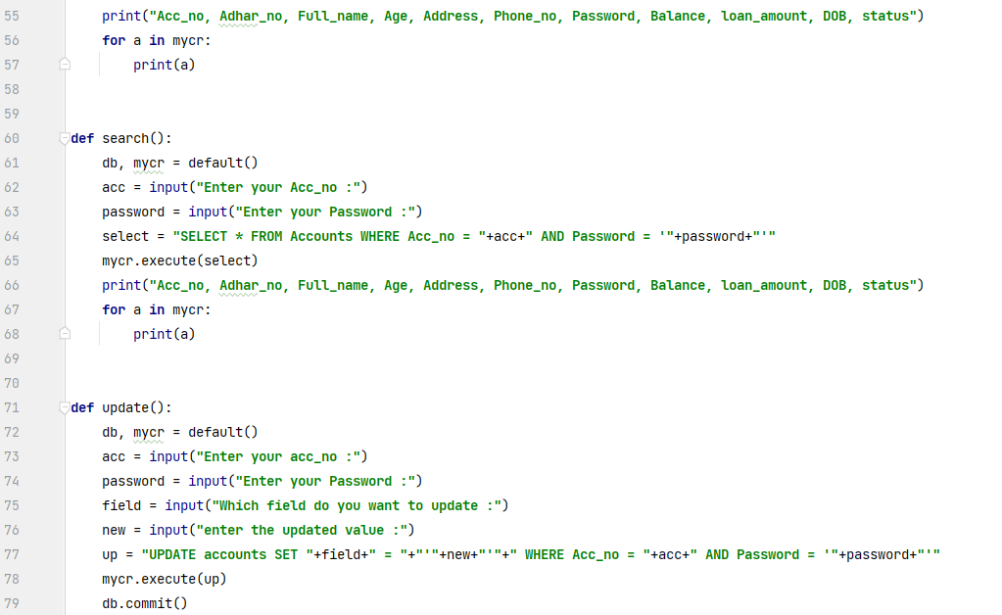 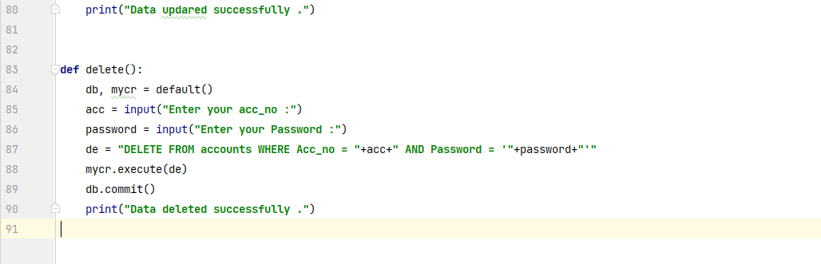

User Defined Module named del_db.py is the program to delete the whole database if wanted.

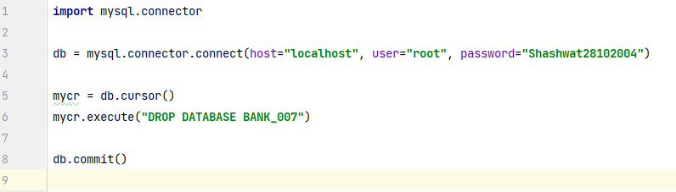

The program named terminal.py is the frontend interactive program, which is a Menu Driven

And it has all the functions that can be performed.

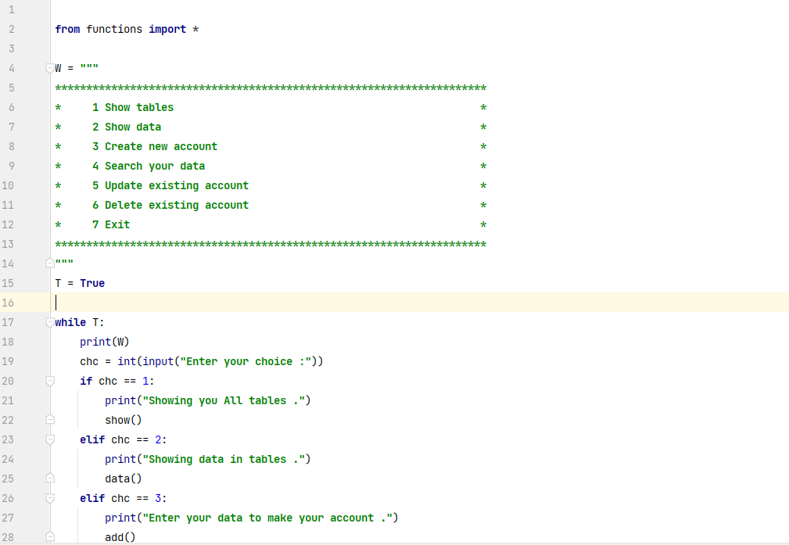 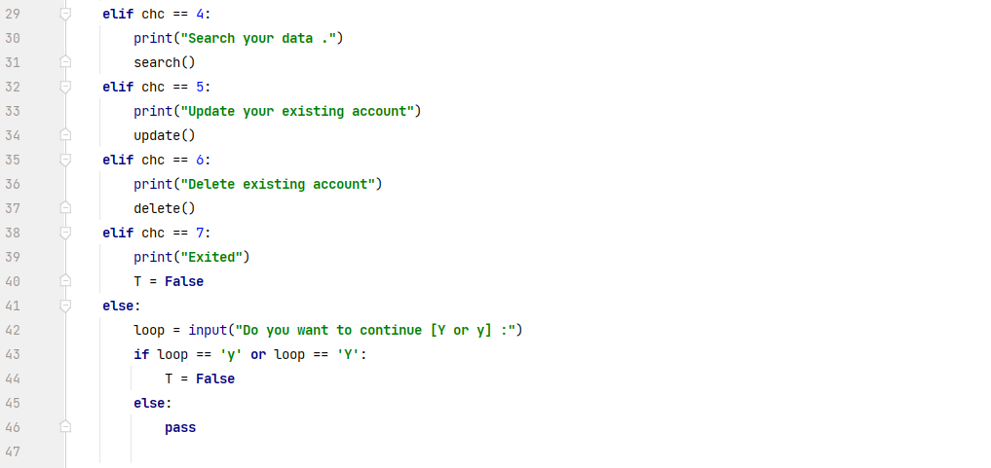

# OUTPUT

Before the execution of M_db.py

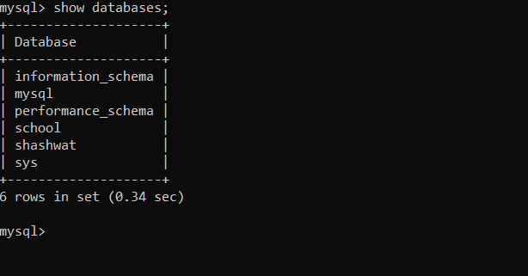

After executing M_db.py

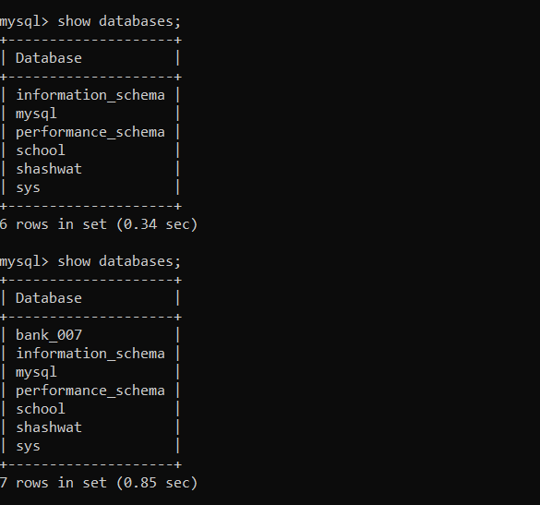

Before the execution of M_st.py

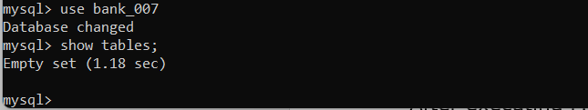

After executing M_st.py

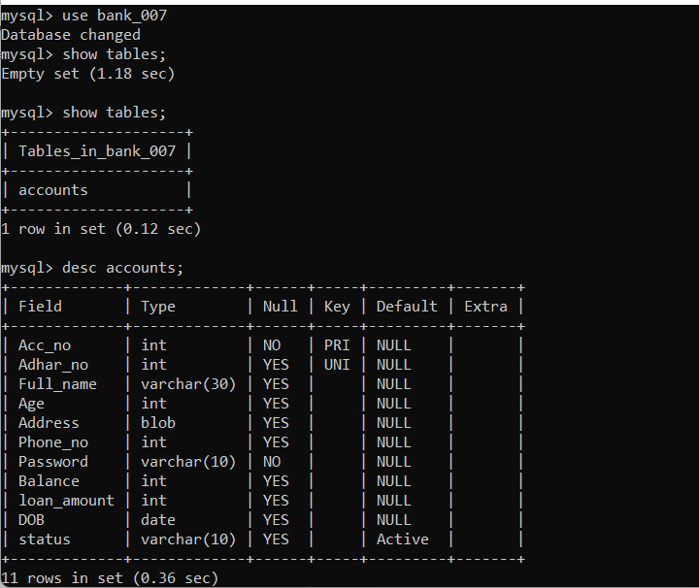

Before the execution of treminal.py

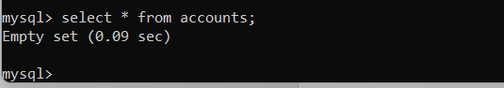

All types of quires were executed in treminal.py 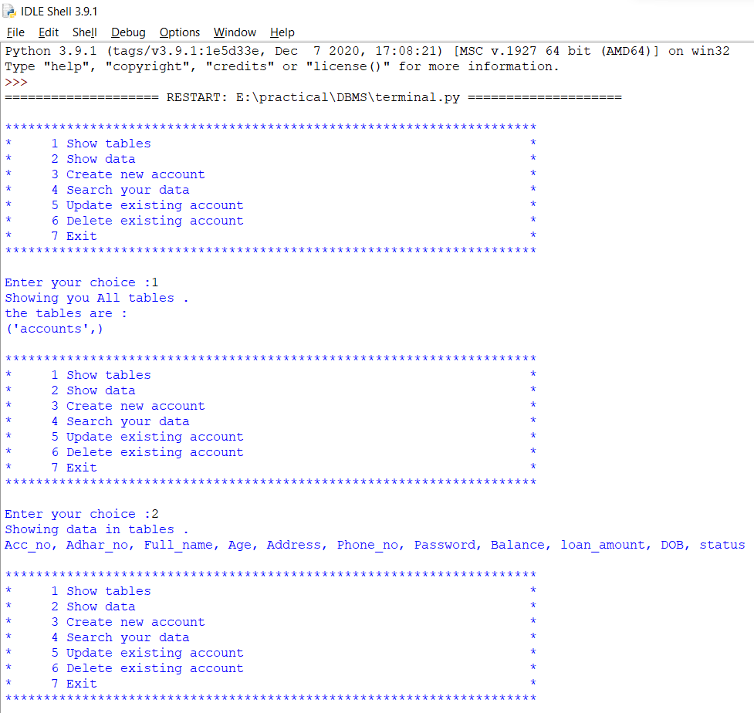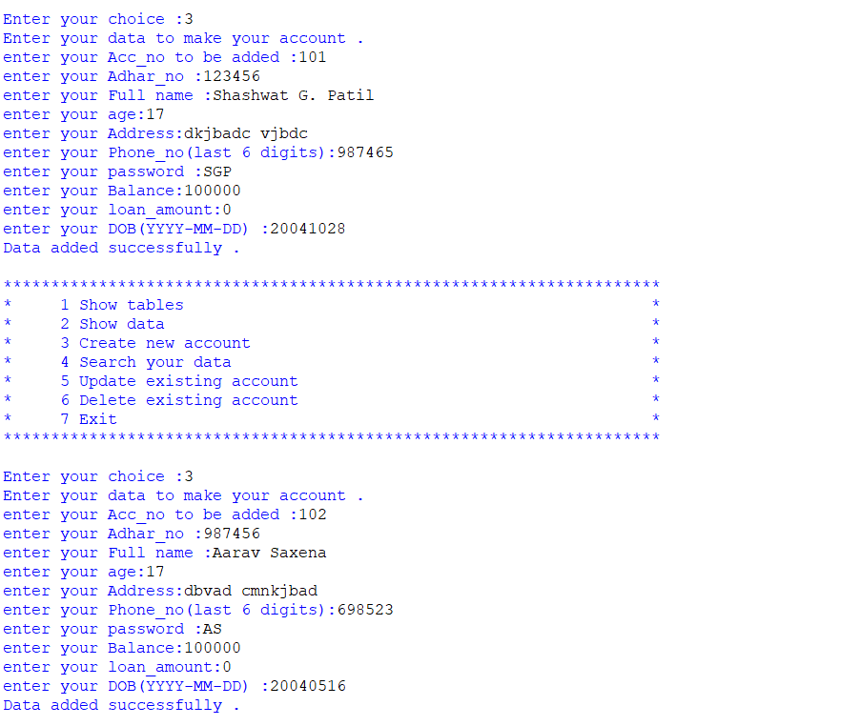 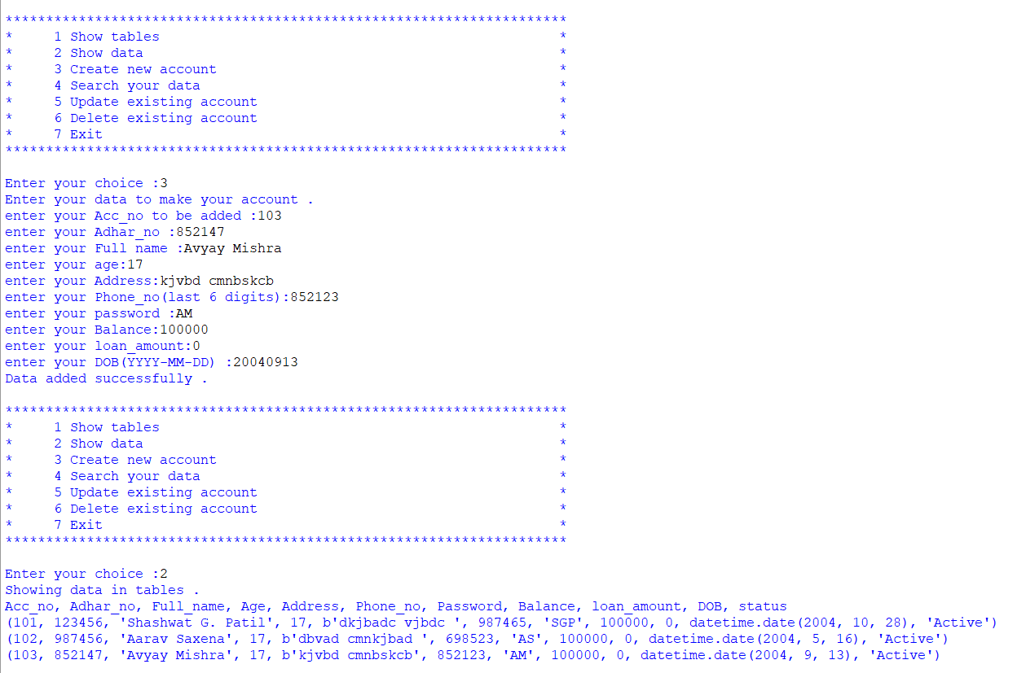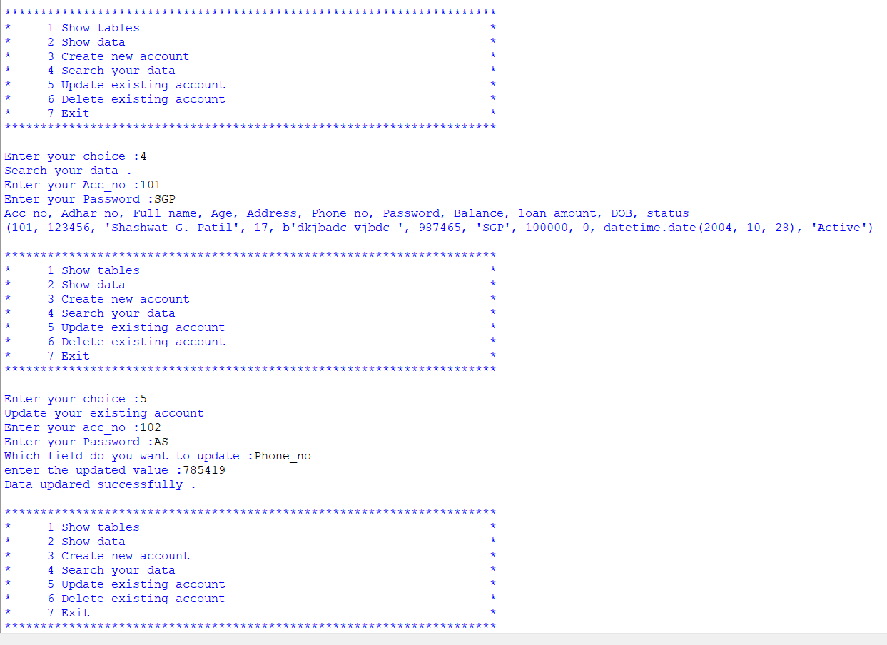 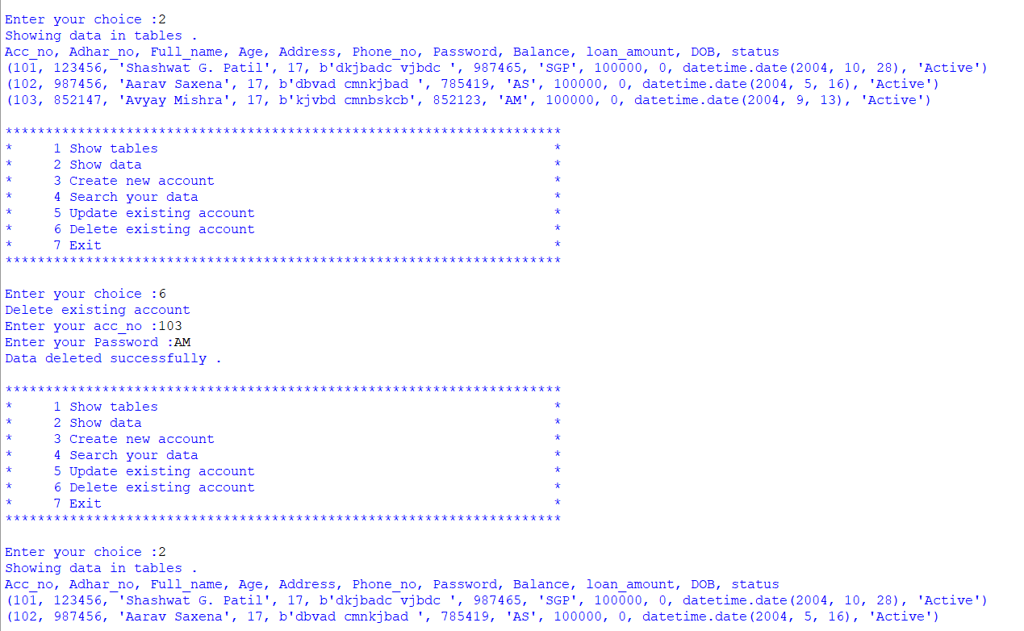 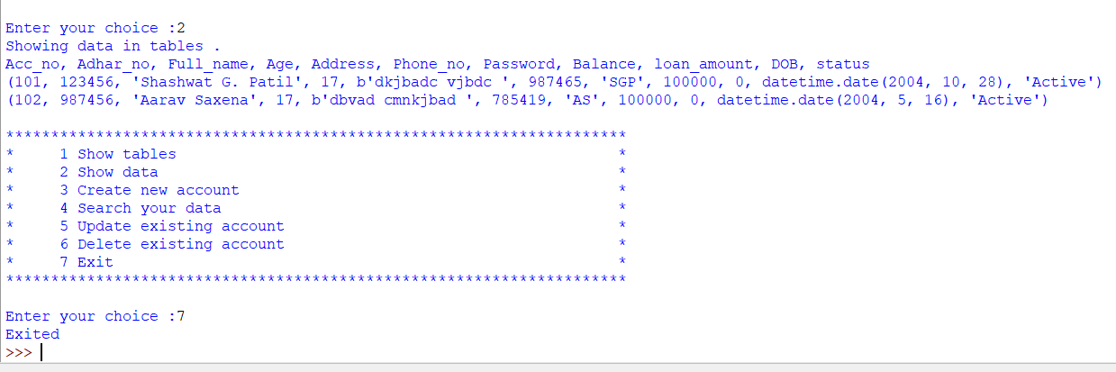 s

## REFERENCES AND BIBLIOGRAPHY

**REFERENCE LINKS**

* [**www.stackoverflow.com**](http://www.stackoverflow.com/)
* [**http://dev.mysql.com/doc/refman/5.7/en/tutorial.html**](http://dev.mysql.com/doc/refman/5.7/en/tutorial.html)
* [**http://www.tutorialspoint.com/mysql/**](http://www.tutorialspoint.com/mysql/)
* [**https://youtu.be/g60QghtJmjY**](https://youtu.be/g60QghtJmjY)
* **https://www.youtube.com/watch?v=HXV3zeQKqGY**

**BIBLIOGRAPHY**

***COMPUTER SCIENCE WITH PYTHON XII (SUMITA ARORA)***